用 So 来描述结果
你可以使用 So 来描述某一行动或时间的结果。注意，原因(he lost his passport)位于结果之前(he went to the embassy)。
 | Shawn lost his passport, so he went to the embassy. | （Shawn 遗失了他的护照，所以去了大使馆。）
注意：So 用于引出结果， because 用于引出原因。观察以下句子的不同之处：
 | Emily recommended Corcovado, so we went there. | （Emily 推荐基督山，所以我们去了那里。）
 | We went to Corcovado because Emily recommended it. | （我们去基督山，因为 Emily 推荐了那里。）

阅读课文，然后回答问题。
Hi!
I'm writing from Las Vegas. What a crazy trip! I got lost when I drove down here. I'm staying in a terrible hotel because the city is so crowded. It's snowing heavily, so I can't drive to the Grand Canyon today. I'll try to take a tour tomorrow. I can't do what I want to do, so I'm having fun playing blackjack at the nice hotels.
See you soon.
Jeremy
Why is Jeremy staying in a terrible hotel?
The city is so crowded.
It is snowing heavily.
He got lost.
Why can't Jeremy visit the Grand Canyon?
He can't find his wallet.
The weather is bad.
There's a problem with the car.
How is Jeremy having fun?
driving to the Grand Canyon
writing from Las Vegas
playing blackjack
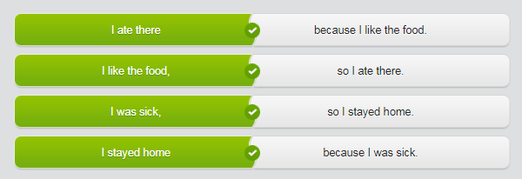

请选择正确的词。
Sarah found great places to eat, so because we're having amazing food.
Eric lost his passport, so because we have to go to the embassy.
I'm going to visit my aunt in Rome because so she's not feeling well.
We're about to take a tour, so because I'll write more later!

